TASK 1 :
#include<iostream>
using namespace std;

int partition( int arr[], int s, int e) {

int pivot = arr[s];

int cnt = 0;
for(int i = s+1; i<=e; i++) {
if(arr[i] <=pivot) {
cnt++;
}
}

//place pivot at right position
int pivotIndex = s + cnt;
swap(arr[pivotIndex], arr[s]);

//left and right wala part smbhal lete h
int i = s, j = e;

while(i < pivotIndex && j > pivotIndex) {

while(arr[i] <= pivot)
{
i++;
}

while(arr[j] > pivot) {
j--;
}

if(i < pivotIndex && j > pivotIndex) {
swap(arr[i++], arr[j--]);
}

}

return pivotIndex;

}

void quickSort(int arr[], int s, int e) {

//base case
if(s >= e)
return ;

//partition karenge
int p = partition(arr, s, e);

//left part sort karo
quickSort(arr, s, p-1);

//right wala part sort karo
quickSort(arr, p+1, e);

}

int main() {

int arr[8] = {5,6,2,-2,6,10,12,15};
int n = 8;

quickSort(arr, 0, n-1);
cout<<"Quick Sort:"<<endl;
for(int i=0; i<n; i++)
{
cout << arr[i] << " ";
} cout << endl;

return 0;
}
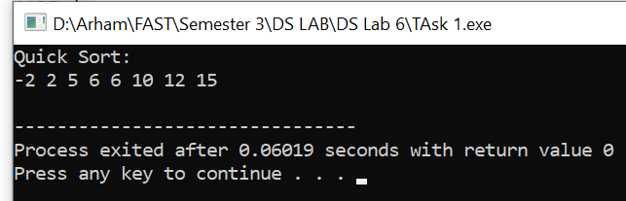

TASK 3:
#include<iostream>
using namespace std;

void merge(int *arr, int s, int mid, int e, bool ascending) {
int len1 = mid - s + 1;
int len2 = e - mid;

int *first = new int[len1];
int *second = new int[len2];

// Copy values
for (int i = 0; i < len1; i++) {
first[i] = arr[s + i];
}

for (int i = 0; i < len2; i++) {
second[i] = arr[mid + 1 + i];
}

// Merge two sorted arrays
int index1 = 0;
int index2 = 0;
int mainArrayIndex = s;

while (index1 < len1 && index2 < len2) {
if ((ascending && first[index1] <= second[index2]) || (!ascending && first[index1] >= second[index2])) {
arr[mainArrayIndex++] = first[index1++];
} else {
arr[mainArrayIndex++] = second[index2++];
}
}

while (index1 < len1) {
arr[mainArrayIndex++] = first[index1++];
}

while (index2 < len2) {
arr[mainArrayIndex++] = second[index2++];
}

delete[] first;
delete[] second;
}

void mergeSort(int *arr, int s, int e, bool ascending) {
if (s < e) {
int mid = s + (e - s) / 2;

// Left part sorting
mergeSort(arr, s, mid, ascending);

// Right part sorting
mergeSort(arr, mid + 1, e, ascending);

// Merge the two halves
merge(arr, s, mid, e, ascending);
}
}

int main() {
int arr[8] = {3, 1, 6, 8, 4, 5, 7, 2};
int n = 8;

mergeSort(arr, 0, n - 1, true); // Ascending order
cout << "Ascending Sort:" << endl;
for (int i = 0; i < n; i++) {
cout << arr[i] << " ";
}
cout << endl;

mergeSort(arr, 0, n - 1, false); // Descending order
cout << "Descending Sort:" << endl;
for (int i = 0; i < n; i++) {
cout << arr[i] << " ";
}
cout << endl;

return 0;
}

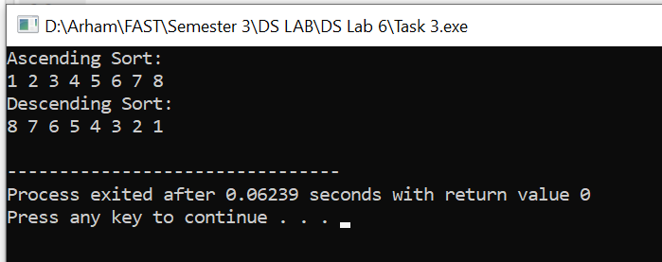

TASK 4:
//ID : 22k-4080
#include <iostream>
using namespace std;

void bubbleSort(int arr[], int n)
{
int i, j;
bool isSwapped;
for (i = 0; i < n - 1; i++) {
isSwapped = false;
for (j = 0; j < n - i - 1; j++) {
if (arr[j] > arr[j + 1]) {
swap(arr[j], arr[j + 1]);
isSwapped = true;
}
}

if (isSwapped == false)
break;
}
}

void sortedArr(int arr[], int size)
{
int i;
for (i = 0; i < size; i++)
cout << " " << arr[i];
}

int BinarySearch(int arr[], int n, int key){

int s = 0;
int e = n-1;
int mid = s + (e-s)/2;

while(s<=e){
if(arr[mid] == key){
return mid;
}

if(key > arr[mid]){
s = mid + 1;
}
else{
e = mid - 1;
}
mid = s + (e-s)/2;
}
return -1;
}

int main(){
int arr[11] = {1,3,12,14,23,34,55,65,80,75,78}; //added 80 as my last two digits of id
bubbleSort(arr,11);
cout<<"Sorted Array: " <<endl;
sortedArr(arr,11);
cout<<endl;
int valueInd = BinarySearch(arr,11,80);

cout<<"The value 80 is at Index "<<valueInd<<endl;
}
